Who Wrote It? Identifying LLMs from Their Responses
Oct 8, 2026 · @Jiya
CMPSC 448 Course Project
Team leader and solo member: Jiya Patel
GitHub repository: github.com/pateljiya0905-pixel/llm-authorship-cmpsc448

Abstract
I show that the family of an LLM (GPT, Claude, Llama, Mistral, or Google) can be identified from its response alone with up to 63.9% accuracy across 5 balanced classes, more than 3x the 20% chance level. Using about 19,700 single turn responses from the LMSYS Chatbot Arena dataset, I trained a CNN, a bidirectional LSTM, and a BiLSTM with max pooling, plus a TF-IDF baseline. The user's prompt alone carries no signal (about 21%), because Arena assigns models to prompts at random. Fingerprints transfer across tasks with only a 3-point drop from general questions to coding, and they come from both word choice and formatting, with word choice contributing more.

1. Problem Definition and Dataset Curation

1.1 Problem
Given a response written by an LLM, I predict which LLM family produced it. This is a 5 class text classification problem. I also ask whether the user's prompt helps (RQ2), whether fingerprints transfer across task domains (RQ3), and which characteristics separate the models (RQ4).

1.2 Data source
I used the public LMSYS Chatbot Arena human preference dataset (lmsys/lmsys-arena-human-preference-55k on Hugging Face). In Chatbot Arena, a user writes a prompt and two randomly chosen models answer it. Each row contains the prompt, both model names, and both responses. I generated no new LLM outputs and used no private data.

1.3 Building (LLM_name, LLM_input, LLM_output) triples
- Each Arena row was split into two triples: (model_a, prompt, response_a) and (model_b, prompt, response_b).
- I kept only single turn conversations so the input and output are clearly paired.
- Model versions were merged into families, following the assignment's definition of LLM families (table below).
- I dropped responses of 20 characters or fewer and removed duplicate responses.
- Each family was capped at 4,000 randomly sampled examples (seed 42) to balance classes.
Family | Models included | Final examples
GPT | gpt-4 (1106-preview, 0613, 0314), gpt-3.5-turbo (0613, 1106) | 4,000
Claude | claude-1, claude-2.0, claude-2.1, claude-instant-1 | 4,000
Llama | llama-2-7b/13b/70b-chat | 4,000
Mistral | mixtral-8x7b-instruct, mistral-medium, mistral-7b-instruct | 4,000
Google | gemini-pro, gemini-pro-dev-api, palm-2 | 3,744
Total |  | 19,744
Google has 3,744 examples because fewer remained after cleaning. I kept them all since the imbalance is small.
I excluded fine tuned derivatives such as Vicuna, Zephyr, WizardLM, and OpenChat. They are built on Llama or Mistral base models, so labeling them as separate families would blur the class boundaries.

1.4 Train, validation, and test split
Every prompt appears twice in the data, once per model in the Arena battle. A random split would put the same prompt in both training and test sets. To prevent this leakage I used a grouped split by prompt (scikit-learn GroupShuffleSplit): about 70% train, 15% validation, 15% test, with no prompt shared across sets.

1.5 Domain labels for RQ3
I labeled each prompt as code or general with a regular expression that matches code fences, programming keywords (def, class, import, #include, SELECT), and words like python, javascript, sql, code, function, and bug. This produced 1,981 code examples and 17,763 general examples, both roughly balanced across families. I spot checked a random sample of code labeled prompts to confirm they were programming tasks.

2. Model and Training Details

2.1 Text preprocessing
I built my own word level tokenizer instead of a standard one, because formatting is likely part of each model's fingerprint:
- Case is kept ("Certainly" and "certainly" stay different).
- Punctuation and markdown symbols (*, #, -, backticks) are separate tokens.
- Line breaks become a special <nl> token.
- The vocabulary is the 30,000 most frequent training tokens that appear at least twice, plus <pad> and <unk>.
- Sequences are truncated or zero padded to 300 tokens.
The vocabulary is built on the training set only, so no test information leaks into it.

2.2 Baseline: TF-IDF + logistic regression
A TF-IDF vectorizer (unigrams and bigrams, 50,000 features, sublinear term frequency) feeds a logistic regression classifier. This gives a quick check that the task is learnable and a reference point for the neural models.

2.3 CNN
I used a text CNN in the style of Kim (2014):
- Embedding layer: 128 dimensions, learned from scratch.
- Three parallel 1D convolutions with kernel sizes 3, 4, and 5, each with 128 filters and ReLU. Each kernel acts as an n-gram detector.
- Global max pooling over time for each convolution, concatenated into a 384 dimension vector.
- Dropout of 0.5, then a linear layer to 5 classes.

2.4 RNN: bidirectional LSTM
- Embedding layer: 128 dimensions.
- One layer bidirectional LSTM with 128 hidden units per direction.
- Sequences are packed (pack_padded_sequence) so the LSTM skips padding tokens and short responses are not drowned out by zeros.
- The final forward and backward hidden states are concatenated (256 dimensions), then dropout 0.5 and a linear layer.
Variant: BiLSTM + max pooling. Same network, but instead of the final hidden state I take the maximum over all time steps of the LSTM outputs, masking out padding. Section 4.1 explains why I added it.

2.5 Training setup
Setting | Value
Loss | Cross entropy
Optimizer | Adam, learning rate 0.001
Batch size | 64
Max epochs | 15
Early stopping | Patience 3 on validation macro F1; best weights restored
Random seed | 42
Hardware | Google Colab, NVIDIA T4 GPU
Metrics | Accuracy and macro F1 on the held out test set
I report macro F1 alongside accuracy so every family counts equally, including the slightly smaller Google class.

3. Results

3.1 RQ1: Can we identify which LLM generated a response?
Yes. Using the response alone, the best model reaches 63.9% accuracy on 5 balanced classes, where random guessing gives 20%.
Model (output only) | Test accuracy | Test macro F1
TF-IDF + logistic regression | 59.8% | 0.595
CNN | 63.3% | 0.637
BiLSTM (final hidden state) | 56.4% | 0.569
BiLSTM + max pooling | 63.9% | 0.641
The CNN and the max pooled BiLSTM both beat the TF-IDF baseline by about 4 points. The standard BiLSTM falls below the baseline; Section 4.1 analyzes why.
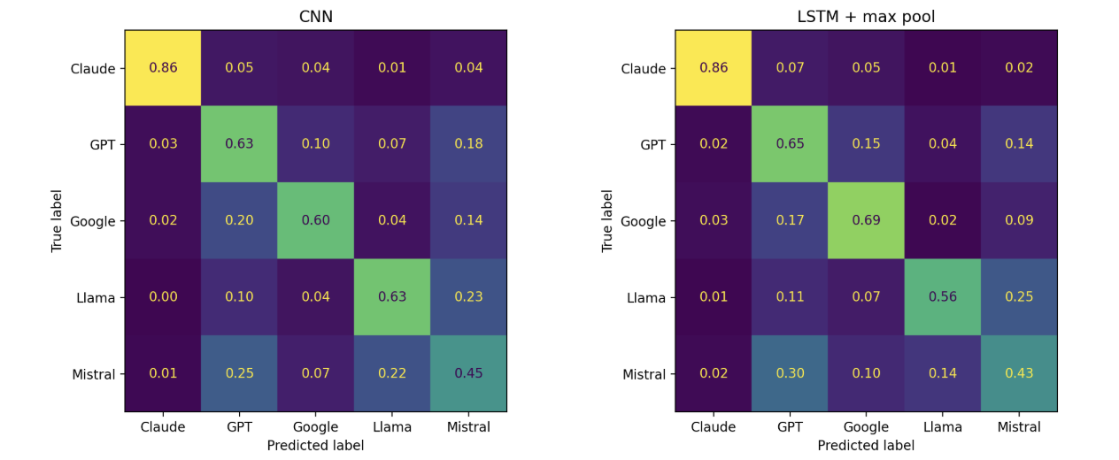
Figure 1. Normalized confusion matrices on the test set for the CNN (left) and BiLSTM + max pooling (right).
The per family pattern is consistent across both models:
- Claude is easiest to identify, with 86% recall in both models and almost no confusion with other families.
- Mistral is hardest (43 to 45% recall). It is confused mainly with GPT (25 to 30%) and Llama (14 to 22%).
- Google is often mistaken for GPT (17 to 20%). Both use heavy bold formatting (Section 4.3).
- Llama is confused mostly with Mistral (23 to 25%).
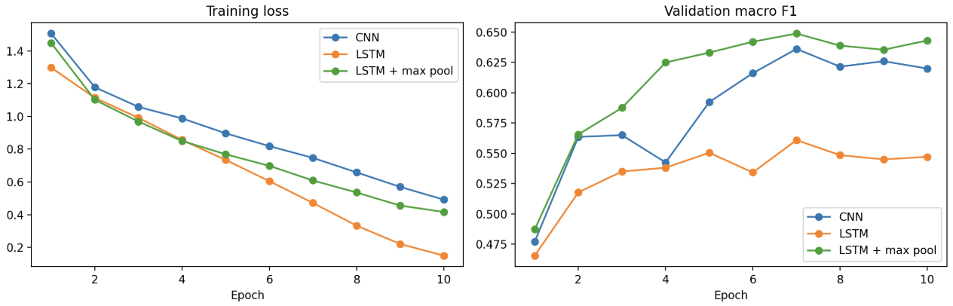
Figure 2. Training loss (left) and validation macro F1 (right) per epoch.
All models overfit after about epoch 7: training loss keeps falling while validation F1 flattens. The standard BiLSTM overfits most, reaching a training loss of 0.15 while its validation F1 stays near 0.55. Early stopping restores the weights from the best validation epoch.

3.2 RQ2: Does the user's prompt help identify the LLM?
No. The prompt alone is no better than random guessing, and adding it to the response slightly lowers accuracy.
Input to classifier | TF-IDF | CNN | BiLSTM
Input only (prompt) | 21.0% | 22.1% | 20.2%
Output only (response) | 59.8% | 63.3% | 56.4%
Input + output | 58.4% | 61.5% | 46.9%
For input + output, the prompt and response were joined with a [SEP] token.
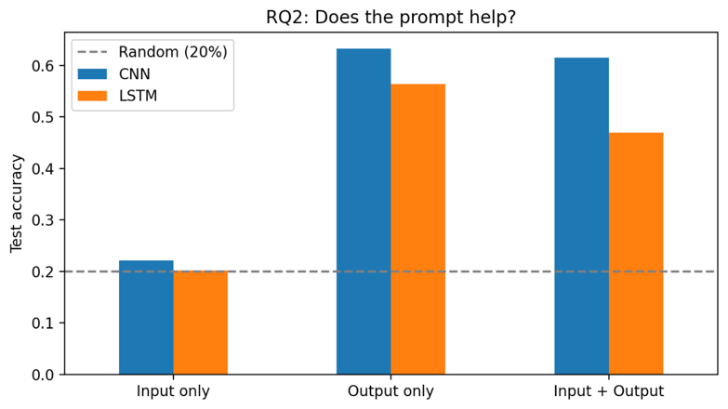
Figure 3. Test accuracy by input type. The dashed line marks random chance (20%).
Answers to the RQ2 questions:
- Can the LLM be predicted from the prompt alone? No. All three models score 20 to 22%, matching chance.
- Does including the input help? No. Accuracy drops by 1.4 points for TF-IDF, 1.8 for the CNN, and 9.5 for the BiLSTM.
- Why does input only fail here? Chatbot Arena assigns two models to each prompt at random, so the prompt is statistically independent of the model label. Input only classification could work on other datasets, for example if each model were tested on its own set of prompts or at different times, but this dataset rules that out by design.

4. In-Depth Analyses

4.1 Why did the standard LSTM underperform?
Adding max pooling raised the BiLSTM from 56.4% to 63.9%, which confirms that LLM fingerprints are local patterns spread through the response.
Hypothesis. The CNN max pools over the whole sequence, so a telltale phrase or formatting habit anywhere in the response can drive the prediction. The standard BiLSTM relies on its final hidden states, which must carry information across up to 300 tokens. Signals early in a long response get diluted.
Test. I kept the same BiLSTM but replaced the final hidden state with max pooling over all time steps.
Result. Accuracy rose by 7.5 points, to slightly above the CNN. Overfitting also dropped: final training loss was 0.42 instead of 0.15, while validation F1 rose from 0.56 to 0.65. The recurrent architecture itself was not the problem; how its outputs were summarized was.
The same effect explains the BiLSTM's large drop in RQ2 (56.4% to 46.9% when the prompt is added). The prompt is placed before the response, so it adds noise the final state must carry through. Because sequences are capped at 300 tokens, a long prompt also pushes part of the response past the cutoff. The CNN, which can pick out response features wherever they appear, lost only 1.8 points.

4.2 RQ3: Do LLM fingerprints generalize across tasks?
Mostly yes. A CNN trained on general prompts loses only 3 points when tested on coding prompts.
Training domain | Training size | In-domain accuracy | Cross-domain accuracy | Drop
General | ~12,400 | 62.9% | 59.8% (on code) | 3.1
Code | ~1,400 | 59.7% | 45.6% (on general) | 14.1
General, size matched | ~1,400 | 45.6% | 43.1% (on code) | 2.5
Controlling for data size. Code to general drops much more, but it also trains on 9x less data. To separate the two effects, I trained on a random general subset the same size as the code set (1,981 examples before splitting). With equal data, both directions reach similar cross-domain accuracy (43 to 46%). The large code to general drop therefore does not mean worse generalization. Code is an easier in-domain task: models differ more in how they format and explain code, so a code trained model scores high on code and falls back on general text. Data size also matters a lot: in-domain general accuracy rises from 45.6% to 62.9% when training data grows from about 1,400 to 12,400 examples.
Which families are consistently identifiable? Per class F1 on the cross-domain test sets:
Family | General to code F1 | Code to general F1
Claude | 0.83 | 0.66
Llama | 0.61 | 0.50
Google | 0.59 | 0.46
GPT | 0.48 | 0.35
Mistral | 0.47 | 0.19
Claude is the most consistent across domains. Mistral is the least: its F1 falls to 0.19 when training on code, so its signal appears more task specific.
General fingerprint or task patterns? The small drop in the general to code direction, and the similar cross-domain scores with matched data, suggest the classifier learns a largely general fingerprint. The weaker Mistral and GPT transfer shows some of the signal is task dependent.
Caveats. The size matched test sets hold only about 300 examples, so those numbers carry a few points of noise. The code labels come from a keyword regex and are not perfect.

4.3 RQ4: What characteristics distinguish the LLMs?
Both structure and word choice separate the models, but word choice carries more of the signal.
Style profile. I computed 11 hand-crafted features per response. Family averages:
Family | Words | Lines | Type-token ratio | Avg word length | Bullets | Bold | Exclamations | Apology rate | "As an AI" rate
Claude | 162 | 14.7 | 0.67 | 5.45 | 3.79 | 0.01 | 0.37 | 8% | 2%
GPT | 192 | 15.1 | 0.68 | 5.41 | 3.37 | 0.98 | 0.30 | 4% | 5%
Google | 181 | 16.4 | 0.63 | 5.45 | 5.05 | 2.12 | 0.15 | 2% | 2%
Llama | 237 | 15.2 | 0.58 | 5.01 | 3.96 | 0.03 | 0.61 | 4% | 3%
Mistral | 204 | 14.0 | 0.61 | 5.88 | 2.84 | 0.11 | 0.33 | 2% | 2%
- Llama writes the longest responses, uses the shortest words, has the lowest vocabulary diversity, and uses the most exclamation marks.
- Claude writes the shortest responses with the highest diversity and apologizes most often.
- Google uses the most bold text (2.1 per response) and the most bullets.
- GPT uses moderate bold and refers to itself as an AI or language model most often.
- Mistral has the longest average word length and the least formatting.
How far do style features alone go? A random forest (300 trees) trained only on these 11 features reached 46.3% test accuracy, well above 20% chance. The most important features were average word length (0.234), word count (0.233), and type-token ratio (0.224).
Ablation: removing signals.
Input | Test accuracy | Change vs. full response
Full response | 63.3% | baseline
Formatting removed (no markdown, bullets, line breaks) | 57.5% | -5.8
First 30 words only | 54.7% | -8.6
11 style features only (random forest) | 46.3% | -17.0
RQ4 questions:
- What signals does the classifier use? Response length, word length, vocabulary diversity, formatting habits such as bold and bullets, and characteristic phrasing. The opening alone is very revealing: the first 30 words keep 86% of full accuracy.
- Linguistic, structural, or both? Both. Structure alone gets 46.3%, and removing formatting costs 5.8 points. But word choice adds about 17 points beyond structure, and most of the accuracy survives without formatting, so linguistic signal dominates.
- Does removing signals reduce performance substantially? Moderately. No single removal destroys the classifier, which suggests the fingerprint is spread across many redundant cues.
Caveats. Type-token ratio falls naturally as text gets longer, so Llama's low diversity is partly a length effect. Random forest importance favors continuous features, so bold ranks low (0.043) even though the profile table shows it is highly distinctive for Google and GPT.

5. Lessons and Experience Learned
- How the data was collected decides what you can learn from it. The RQ2 result (prompt alone is random) is not a fact about LLMs in general. It comes from Arena's random model assignment. Reading how a dataset was built before running experiments saved me from misinterpreting this result.
- Watch for leakage that is easy to miss. Every prompt appeared twice in the data. A normal random split would have put the same prompt in train and test. Splitting by prompt group was a one line fix, but I only caught it by inspecting how rows were constructed.
- Always start with a simple baseline. TF-IDF with logistic regression took a minute to run and reached 59.8%. It confirmed the task was learnable and showed that a neural model is only worth it if it clearly beats that number. The standard LSTM did not.
- Small architecture choices can matter more than model type. Switching the LSTM from its final hidden state to max pooling gained 7.5 points. Forming a hypothesis about why a model fails, then testing that one change, was more useful than tuning hyperparameters blindly.
- Overfitting shows up fast on text. Training loss kept falling while validation F1 stalled after about 7 epochs. Early stopping on validation F1 and dropout were necessary, and the training curves made the problem obvious.
- Check for confounds before drawing conclusions. The 14 point drop from code to general first looked like poor generalization. The size matched control showed it was mostly an effect of training data size and an easier in-domain task.
- Feature analysis explains what accuracy cannot. Accuracy says the models are distinguishable; the style profile and ablations show how. They also showed that some signals overlap, so no single feature removal breaks the classifier.
Limitations and future work. The dataset covers 2023 to early 2024 model versions, so results may not hold for newer models. Labels are at the family level, which hides differences between versions such as GPT-3.5 and GPT-4. Domain labels come from a keyword regex. Future work could use pretrained embeddings or a fine tuned transformer, classify at the version level, and test whether fingerprints survive paraphrasing.
Use of AI tools. I used an AI assistant to brainstorm the experiment design, debug code, and interpret some results.

References
- LMArena (formerly LMSYS). arena-human-preference-55k dataset. Hugging Face. huggingface.co/datasets/lmarena-ai/arena-human-preference-55k
- Chiang, W.-L., et al. (2024). Chatbot Arena: An Open Platform for Evaluating LLMs by Human Preference. ICML 2024.
- Kim, Y. (2014). Convolutional Neural Networks for Sentence Classification. EMNLP 2014.
- Hochreiter, S., and Schmidhuber, J. (1997). Long Short-Term Memory. Neural Computation, 9(8).
- Schuster, M., and Paliwal, K. K. (1997). Bidirectional Recurrent Neural Networks. IEEE Transactions on Signal Processing, 45(11).
- Paszke, A., et al. (2019). PyTorch: An Imperative Style, High-Performance Deep Learning Library. NeurIPS 2019.
- Pedregosa, F., et al. (2011). Scikit-learn: Machine Learning in Python. JMLR, 12.

